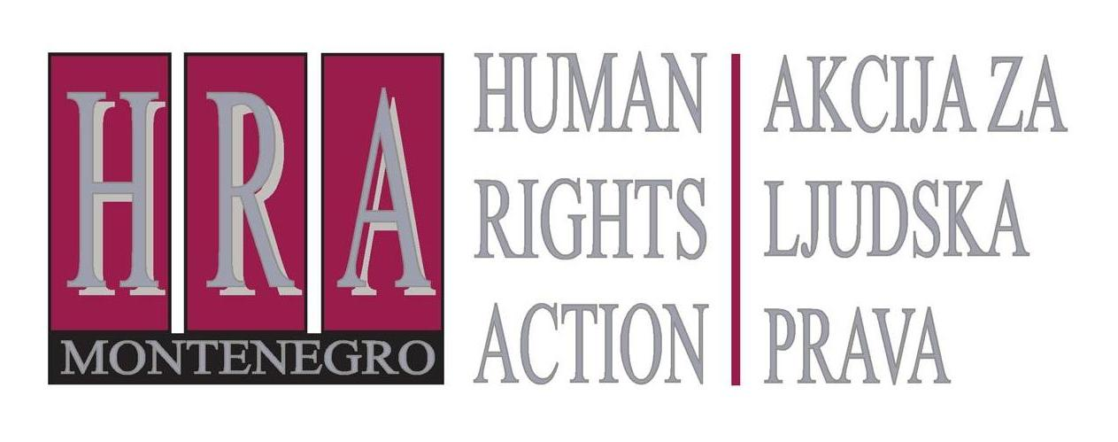

European Court of Human Rights judgments on the right to freedom of expression

Bulletin IV: ROUND-UP OF FREEDOM OF EXPRESSION JUDGEMENTS: OCTOBER 2012
15 November 2012

During October 2012, the European Court adopted judgments in the following freedom of expression cases:
- Karpetas v. Greece (no. 6086/10), 30 October 2012
- Jucha and Żak v. Poland (no. 19127/06),23 October 2012
- Smolorz v. Poland (no. 17446/07), 16 October 2012
- Szima v. Hungary (no. 29723/11), 9 October 2012
- Alkaya v. Turkey (no. 42811/06), 9 October 2012
- Yordanova and Toshev v. Bulgaria (no. 5126/05), 2 October 2012
- Önal v. Turkey (nos. 41445/04 and 41453/04), 2 October 2012
- Najafli v. Azerbaijan (no. 2594/07), 2 October 2012
The judgment in Alkaya v. Turkey has been reported separately (in the bulletin on privacy).
The other judgments concerned the following issues:
- Karpetas v. Greece (no. 6086/10), 30 October 2012:
This concerned a Greek lawyer who had been convicted for defamation of a prosecutor and an investigating judge who had released on bail someone who had assaulted the lawyer in his office. Mr Karpetas suggested that the prosecutor and judge had taken bribes from his assailant. Both lodged proceedings for defamation, and the lawyer was ordered to pay 15,000 Euros (EUR) to the prosecutor (the proceedings concerning the investigating judge are still pending).
The European Court held that this did not constitute a violation of the lawyer’s right to freedom of expression: the applicant was an experienced lawyer and he had lodged formal complaints against the prosecutor and judge which had been dismissed. Applicant’s accusations had been repeated in the press and spread to a large audience and clearly implied that the judge and prosecutor were corrupt individuals. Applicant had no factual basis for his allegation whatsoever. The Court also took into account that the administration of justice should be protected, and accusations of corruption should not be made lightly.
- Jucha and Żak v. Poland (no. 19127/06), 23 October 2012:
The applicants are the editor-in-chief and a journalist working for the Polish newspaper, TEMI. They had been convicted for defaming a local councillor in an article alleging that he had broken the law by disclosing confidential information and committing financial fraud in his election campaign.
The Court held that the conviction violated the right to freedom of expression of the journalists: while their articles had been critical and the allegations serious, the journalists had acted responsibly and in good faith. They had approached a significant number of the councillor’s former collaborators and fellow local politicians to have as objective a picture of him as possible. They had requested him to comment on court cases in which he had been involved; however, their requests were refused. Furthermore, the content and the tone of the articles were on the whole fairly balanced and could not be said to constitute a gratuitous personal attack. The domestic courts had only looked at certain passages in isolation and had disregarded the general critical opinion about the councillor’s activities, which was supported by information from various sources. Given the councillor’s controversial standing in the community, evidenced by a statement of the municipal council signed by thirty-four councillors, he should have displayed a greater degree of tolerance of scathing remarks about his performance or policies. The European Court also noted that a degree of exaggeration and immoderation is allowed for those who take part in a public debate on issues of general interest.
- Smolorz v. Poland (application no. 17446/07), 16 October 2012:
This concerned a Polish journalist who had published an article headlined, “Architect and master of self-satisfaction ”on the subject of certain buildings designed by communist era architects in Katowice, Poland. The article was a response to remarks made by one of the architects, Mr Jarecki, in an interview published the previous week in the same newspaper, under the headline “The joy of demolishing”. The journalist criticised buildings that were supposed to be symbols of modernity when built, but which even then, he argued, gave pleasure only to their architects and “the apparatchiks of the communist party”. He criticised their “ugliness” and their “Bolshevik-ridden aesthetics”. Mr Jarecki, who had been named in the article, brought an action against the journalist and won an apology and payment of his legal costs.
The European Court found that the journalist’s right to freedom of expression had been violated. It noted that the article had been published in the context of a debate concerning the urban appearance of Katowice, and was thus a matter of public interest. Furthermore, Mr Jarescki was held to be a public figure for whom the limits of permissible criticism were wider than in relation to private citizens. The Court also considered that the discussion in which they were involved focused on issues which could be described as “historical”. With regard to the nature of the remarks, the Court considered that the issue under discussion was by its nature abstract and very subjective, and was not easily susceptible to tangible and objective assessment. To require the journalist to demonstrate the truth of his statements– which conveyed his opinion on a matter of aesthetics – was not reasonable. Furthermore, the European Court reiterated that a degree of exaggeration, or even provocation, was permitted to the press, which had a duty to comment on matters of public interest. The use of sarcasm and irony were perfectly compatible with the exercise of a journalist’s freedom of expression. The Court also noted that the language used was neither vulgar nor intentionally excessive and that the journalist had criticised the architect’s professional expertise, and had not made gratuitous personal statements. Finally, although the penalty imposed had been minor, the important point was that he had been required to apologise publicly for his comments.
- Szima v. Hungary (no. 29723/11), 9 October 2012:
This concerned a retired Hungarian police officer who had posted critical comments on the website of the police union. In particular, she had complained about certain labour-issues – such as outstanding pay due to police staff – and had alleged nepotism and undue political influence in the force. Domestic courts imposed a fine and demoted her.
The European Court held that some of the applicant’s statements, for example related to pay, concerned legitimate trade union activities, whilst other statements – in particular those criticising certain police officers as being in the service of political elements – did not. The Court also considered that as a senior police officer, the applicant should have observed greater care in her public statements since they could cause insubordination within the police force: the applicant had considerable influence on trade union members and other servicemen, among other things by controlling the trade union’s website. Considering the minor nature of the sanction imposed, the Court concluded that applicant’s right to freedom of expression had not been violated.
The President of the Section of the Court that issued the judgment strongly disagreed with the finding of the majority and issued a separate, dissenting judgment.
- Yordanova and Toshev v. Bulgaria (no. 5126/05), 2 October 2012:
The applicants are a journalist and the editor in chief of the Bulgarian newspaper, Trud. They had published articles that were critical of a former employee of the Ministry of Internal Affairs who had been investigated for abuse of office. The journalists had been found guilty of defamation for those articles.
The European Court found that their conviction for defamation constituted a violation of their right to freedom of expression. It noted that the articles reflected statements of the police and the prosecuting authorities concerning allegations of serious misconduct, and that there was no doubt that they were of high public interest. While freedom of expression does come with “duties and responsibilities”, the Court held that in this case, the journalists had complied with these duties: the journalists had relied on official police documents the truth of which they should not have to verify, and information about the case was published also by the press service of the Ministry of Internal Affairs and was later disseminated by the Bulgarian Telegraph Agency. The journalists did not adopt the allegations as their own; and while the journalists had engaged in a degree of ‘sensationalising’ the story this had been legitimate in the context of their job of reporting the news. The Court held that journalists cannot be expected to act with total objectivity and must be allowed some degree of exaggeration or even provocation, and the fact that the text of the articles and their captions contained expressions designed to attract the public’s attention did not in itself present a problem. No gratuitously offensive language was used. Finally, the Court emphasised that national courts, in ruling on cases such as these, must take into account the likely impact of their rulings on the media in general.

- Önal v. Turkey (nos. 41445/04 and 41453/04), 2 October 2012:
This case concerned the conviction of the director of a publishing house for publications that had allegedly incited hatred and hostility. The applicant had published the biography of a businessman of Kurdish origin accused of drug trafficking and belonging to the illegal armed organisation PKK (Kurdistan Workers’ Party); as well as a translation of a book originally published in Swedish, concerning the Alevis of Dersim. Domestic courts had found that both publications divided the people between Turks and Kurds, Alevis and Sunnis, and thus incited hatred and hostility.
The European Court found that both convictions violated the publisher’s right to freedom of expression. It held that while certain passages in the first book painted an extremely negative picture of the Turkish state, and thus gave the narrative a hostile tone, it stressed that the Kurdish ‘problem’ had to be solved by peaceful means. The book did not present a ‘call to arms’. As regards the second book, the Court noted that this traced the social and cultural history of the Alevis. It provided a perspective on the issues that have afflicted the Alevis from a different context than that ‘normally’ held, and the Court emphasised that by doing this it promoted diversity of opinion and fulfilled the public’s right to receive different ideas and information from a variety of sources. Both books clearly intended to inform the public on important points of public policy, and neither aimed to instigate violence in any way nor did they seek to instil hatred.
- Najafli v. Azerbaijan (application no. 2594/07), 2 October 2012:
This concerned a journalist who had been beaten by the police while covering an unauthorised opposition demonstration in Baku. The Court found that the physical ill-treatment by State agents of journalists carrying out their professional duties had seriously hampered the exercise of their right to receive and impart information. Irrespective of whether there had been any actual intention to interfere with Mr Najafli’s journalistic activity, he had been subjected to unnecessary and excessive use of force, despite having made clear efforts to identify himself as a journalist at work. His right to freedom of expression had therefore been violated, as well as his right to be free from torture and other degrading treatment. The European Court emphasised that it was the role of the press to impart information and ideas on matters of public interest and that the public had a right to receive them, including concerning opposition gatherings and demonstrations. This was essential for the development of any democratic society and for the press to play its vital “public watchdog” role.

Prepared by Peter Noorlander, Director of Media Law Defence Initiative, London in cooperation with HRA


Bulletins are published within the project “Monitoring of Journalistic Self-Regulatory Bodies in Montenegro” funded by the British Embassy Podgorica.

