

Bulletin XLIII: SPECIAL EDITION, “WHEN SATIRE INCITES HATRED”, PETER NOORLANDER

21 January 2015

Following the appalling murder of cartoonists, journalists and police at French satirical magazine Charlie Hebdo, as well as several hostages in a related attack on a Jewish supermarket, the debate about whether some of Charlie Hebdo’s cartoons go too far and constitute “hate speech” has reignited. Were their cartoons racist? Did they offend Islam? Is there a right not to be offended, and where is the line between offence, insult and incitement of hatred?
All but the staunchest defenders of free speech will admit that the right to freedom of expression is not unlimited. Even in the US, which has the strongest constitutional protection for free speech of any country in the world, there are limits. But where is the line to be drawn, particularly as regards offensive speech and incitement to hatred? A closer look at recent French cases as well as decisions from the European Court of Human Rights may help inform this debate.
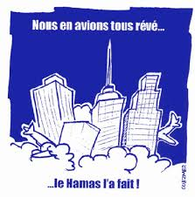
France’s hate speech laws are very strict. Insulting individuals on the basis of their religion or inciting hatred is a criminal offence, as is “glorifying” terrorism. The laws are in frequent use. In 2001 a cartoonist was fined for a satirising the attack on the Twin Towers, despite arguing that he intended to criticise US politics. More recently, comedian-turned-activist Dieudonné M'bala M'bala has had several scrapes with the law for perceived anti-semitism and is currently under police investigation for an ironic post on his Facebook page in which he said, “As far as I am concerned, I feel Charlie Coulibaly” (seen as indicating sympathy for both Charlie Hebdo and one of the murderers).
This cartoon earned French cartoonist Denis Leroy a €1,500 fine
Over the years, Charlie Hebdo has been sued nearly 50 times in the French courts, mostly by religious groups. Catholic groups have been the most litigious, followed by Islamic associations and right-wing extremists, whom Charlie Hebdo also offend with great vigour and enthusiasm. A number of these cases have raised the question whether cartoons or texts published in Charlie Hebdo constituted hate speech.
The case that probably best illustrates the debate is the one that followed Charlie Hebdo’s publication in 2006 of the so-called “Mohamed cartoons” that had initially been published in a Danish newspaper, Jyllands Posten. A coalition of Islamic groups sued Charlie Hebdo, arguing that three of the cartoons in particular insulted their religious beliefs. The first, which appeared on the cover of the magazine, showed the prophet Mohamed crying and saying, “It’s hard being loved by idiots.” The caption read, “Mohamed overwhelmed by fundamentalists.” The second showed the prophet Mohamed apparently guarding the gates of heaven and saying to a line of suicide bombers, “Stop! Stop! We have run out of virgins!” The third showed the prophet Mohamed wearing a turban in which a bomb is concealed with the fuse lit.
The Paris “Tribunal de Grande Instance” ruled in 2007 that the cartoons did not incite hatred and could not be seen as “hate speech”. The court emphasised the importance of protecting free speech in a democratic society, and the need to tolerate the viewpoints of others – including viewpoints that some may find offensive. The court also noted that the cartoons appeared in a satirical magazine which the public was free to buy or not to buy – they didn’t appear on billboards by the side of the road which everyone would see. As for the cartoons themselves, the court ruled that two of the three were not aimed at all Muslims, but merely satirised violent extremists. This was not hate speech.
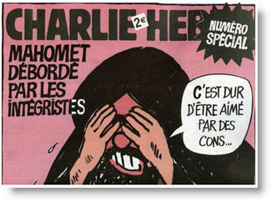
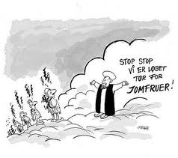
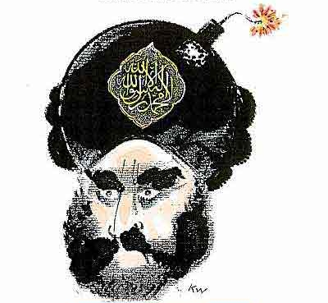
The court held that the third cartoon, showing the prophet Mohamed with a bomb in his turban, was much ‘darker’ than the others and could be seen as offensive to all Muslims. However, its re-publication was justified because of the international debate at the time around the “Mohamed cartoons” – its newsworthiness and Charlie Hebdo’s right to comment and contribute to this debate meant that the publication did not intend to incite hatred and could not be seen as ‘hate speech’.
European human rights law treats cases such as this with some caution. The European Convention on Human Rights protects the right to freedom of expression as well as the right to freedom of religion, and condemns incitement to hatred. The European Court of Human Rights has dealt with a few cases involving inflammatory books, cartoons or artwork. In a 1991 case concerning a book by Salman Rushdie, the Satanic Verses, a group of Muslims complained that the failure by the UK to ban the book – which they considered to be clearly blasphemous – violated their right to peaceful enjoyment of their religious beliefs. Their application was rejected on the grounds that they could not rely on their own right to freedom of religion to enforce a ban – freedom of religion did not include a right not to be offended. In a later case against Poland involving a picture of Jesus and Mary wearing gas masks, a similar complaint was also rejected. The European Commission on Human Rights held in this case that, “members of a religious community must tolerate and accept the denial by others of their religious beliefs and even the propagation by others of doctrines hostile to their faith.”
When the art in question isn’t seen as having some broader societal value, the Court has been less sympathetic. In 1994, the Court upheld the ban in Austria of a film which presented the Christian god as old, crippled and ineffective; Jesus as a somewhat dim “mummy's boy” and the Virgin Mary as promiscuous. They are all portrayed as conspiring with the devil and the Austrian authorities had banned the film on the grounds that it insulted Christians. The European Court held that this did not violate the right to freedom of expression, because the film makers had been “gratuitously offensive” and the Austrian authorities had been correct to “prevent that some people should feel the object of attacks on their religious beliefs in an unwarranted and offensive manner.” In contrast, in a 2006 ruling the Court held that a conviction for religious insult for a French newspaper article which criticised Catholic church doctrine and pointed out links with the origins of the Holocaust did violate the right to freedom of expression. The Court considered that this article had contributed to a debate on the various possible reasons behind the holocaust, and that this was clearly an issue of public interest.
This gives some clear guidance: democratic societies need to be able to discuss current affairs and issues that concern us all, and we need to accept that some of us hold strong opinions. That’s what tolerance and pluralism is all about. Merely portraying a religious figure such as the prophet Mohamed is allowed, even if some believers would see that as an insult. Inciting hatred against individuals simply on grounds of their religious beliefs oversteps the line; but satirising violent extremists within a religion is part and parcel of democratic society. This means that cartoonists have every right to satirise Islamic fundamentalism, an issue that has dominated public debate ever since the early 2000s.
The French court’s 2007 Charlie Hebdo ruling also has a very simple, pragmatic message: if you don’t like the cartoons, don’t buy the magazine.
Peter Noorlander

Peter Noorlander is a lawyer and Director of Media Legal Defence Initiative in London, author of HRA bulletins on European Court of Human Rights case law on the right to freedom of expression


Bulletins are published within the project “Support for Understanding Journalistic Ethics and Freedom of Expression” funded by the U.S. Embassy Podgorica.

